The Role of Probiotics in The Prevention of Colorectal Cancer

Muhammad Ridho Mandiri1*, Wendy P2, Pariyana3

1Faculty of Medicine, Universitas Sriwijaya, Palembang, Indonesia

2Department of Surgery, Faculty of Medicine, Universitas Sriwijaya, Palembang, Indonesia

3Department of Public Health, Faculty of Medicine, Universitas Sriwijaya, Palembang, Indonesia

E-mail : [edo310101@gmail.com](mailto:edo310101@gmail.com)

# Abstract

Colorectal cancer (CRC) is the most common malignant tumor of the colon and rectum in the gastrointestinal tract which is one of the major health problems in the world with the fourth leading cause of death in the world. Various sources state that the incidence of CRC is caused by an imbalance of intestinal micro flora. It is important to maintain a balance of live microorganisms in sufficient quantities to provide health benefits called probiotics. Probiotics can maintain intestinal integrity, regulate bowel movements, increase lactose intolerance, thereby boosting immunity and helping prevent overgrowth of harmful bacteria and fungal infections. Through non-specific physiological mechanisms and immunological mechanisms, probiotics have roles such as initiating antiproliferative responses and apoptosis of CRC cells, supporting the function of the intestinal mucosal barrier by producing mucus, inhibiting the enzymatic activity of pathogenic bacteria such as β-glucuronidase, β-glucosidase, azoreductase, and nitroreductase so as to prevent colorectal cancer. In addition, it is necessary to make a diet and regulate a good diet in order to create homeostasis of microorganisms, normal intestinal flora.

**Keywords:** probiotics, prevention, colorectal cancer, scfa

# 1. Introduction

Colorectal cancer (CRC) is the most common malignant tumor of the colon and rectum in the gastrointestinal tract that becomes One of the world's major health problems.1 Epidemiology, cases of colorectal cancer in Indonesia occupy the third position after lung and breast cancer and the fourth leading cause of death in the world.2 The cause of colorectal cancer cases is not known with certainty, but it is a multifactorial disease associated with low physical activity, obesity or high BMI, a diet high in fat and low in fiber, alcohol consumption, smoking, use of nonsteroidal anti-inflammatory drugs and family history. Several epidemiological studies explain that there are racial and dietary factors that play a role in the pathogenesis of colorectal cancer. Consumption of red meat and animal fat shows an increased risk of colorectal cancer, while a diet rich in fruits and vegetables can protect or prevent colorectal cancer.3 Surgery is the main treatment in CRC. However, the possibility of postoperative trauma, disruption of the normal intestinal flora, reduced intestinal barrier function, increased occurrence of systemic inflammation, and decreased immune function, are risks after surgery.4 Evidence from multiple sources supports the assumption that colorectal cancer is caused by an imbalance of the intestinal micro flora. At birth, the GI tract is colonized by microbes and remains home to several populations of microorganisms throughout the host's life. The 'normal' gut microflora consists of bacterial species with morphological, physiological and genetic properties that allow them to colonize and multiply under specific conditions and locations, coexist with other colonizing microorganisms and competitively inhibit the growth of pathogenic bacteria. Nevertheless, some environmental factors such as diet and medications can alter the composition of the normal microbiota, with consequent microbia and negative implications for an individual's health. The colonic microflora is very rich and dominated by strict anaerobic bacteria such as  *Bacteroides spp., Fusobacterium spp., Clostridium spp.,* and many others.5 Probiotic bacteria can be defined as "live microorganisms that when administered in sufficient quantities provide health benefits to the host". 6 There are about 100 trillion microorganisms essential for gastrointestinal homeostasis. Gut microbiota plays an important role in improving food absorption, resistance to infection, boosting the gut immune system, and regulation of host metabolism.7 With the many benefits of probiotics especially in terms of colorectal cancer prevention, this is the purpose of creating this literature.

# 2. Results and Discussions

# Probiotic

According to the Food and Agriculture Organization of the United Nations (FAO) and the World Health Organization (WHO), probiotics are "live microorganisms, providing health benefits to the host when administered in adequate amounts". So, probiotics are live bacteria that can be added to the human diet as supplements that can potentially provide health benefits. An estimated 100 trillion different bacteria divided into 1000 different species inhabit the human digestive tract.8 The human gut microbiome is believed to have about three million functional genes compared to 23,000 genes in humans; The genome of this much larger microbiome has capabilities. greater functionality in modulating human physiology.9 The human microbiome is now considered a fully functional auxiliary organ that is highly adaptable, flexible, and organized with key functions for human health.9

1. **The Rationale behind the Use of Probiotics in Cancer**

Genetics and environmental factors are the two main contributing factors to CRC. Other risks include IBD and gut microbial composition. The composition of microbiota has been shown to influence the following processes: epithelial cell proliferation and differentiation, production of bioactive food products and nutrients, prevention of overgrowth of pathogenic organisms, and stimulation of immunity. For the most part, the exact mechanism by which microbiota composition is associated with CRC remains unknown. Currently, studies have found evidence that normal microbiota is made up of beneficial and pathogenic bacteria. If pathogenic bacteria grow too fast, an inflammatory process can be triggered, resulting in the production of carcinogenic compounds. It's important to recognize the role of healthy flora in protecting us from adverse health conditions. The bacteria in our gut compete with potential invaders for space and nutrients and produce bacteriocins, which act as antibacterials to eliminate harmful bacteria from our gut.10 Thus, it is important that the balance of the normal flora of the intestine remains at homeostasis.

Dysbiosis, an imbalance of microbes in the gut or malabsorption in our bodies, can be caused by environmental factors (such as diet, infections, and antibiotics). Overcoming dysbiosis and the effects of harmful bacteria with replacement through the use of probiotics results in protection against CRC or therapeutic responses to various drugs in CRC. Probiotics is a term used to describe healthy bacteria that have beneficial effects on the body; lactic acid-producing bacteria (BAL) such as *Lactobacillus* and *Bifidobacterium*  species are the most common types found in the gut.11 In studies by Yuan et al., probiotics with this species were used to show improved response to drugs. Probiotics maintain intestinal integrity, regulate bowel movements, promote lactose intolerance, thereby boosting immunity and helping prevent overgrowth of harmful bacteria and fungal infections.

Other studies highlight the fact that CRC patients have an abundance of Fusobacterium.12 This can be leveraged to detect CRC polyps earlier than current diagnostic methods. With regard to the mechanism by which Fusobacterium promotes carcinogenesis, it has been suggested that, due to its interaction with E-cadherin, it increases the malignant potential of CRC by increasing inflammation and antagonizing the immune function of T cells. Another proposed mechanism is that Fusobacteria may promote colorectal cancer by activating Wnt/α-catenin signaling and impairing ROS DNA production and oncogen12 activation. Others have reported enterotoxigenic enrichment of Bacteroides fragilis and Enterococcus faecalis in the feces of patients with colorectal cancer compared to healthy controls13. E. coli has also been shown to promote the onset of CRC by expressing polyketide synthase genes involved in inflammation, cell proliferation, and epithelial cell injury through direct invasion of epithelial cell layer.14 The polyketide synthase gene also increases cyclooxygenase 2 (COX-2) activity, which is associated with CRC through several additional studies.14 There are many toxins produced as a result of microbiota dysbiosis. One such toxin is B. fragilis toxin (BFT). BFT interacts with Wnt/B-catenin and nuclear factor kappa B at the molecular level; All three mediate inflammation and cell proliferation, thereby contributing to carcinogenesis.12 Toxins can also have a direct damaging effect on DNA. Another example is poison polyketide peptides, which create gene instability. An additional mechanism involved in carcinogenesis when dysbiosis occurs is the fact that pathogenic bacteria contain enzymes such as beta glucuronidase and azoreductase. These enzymes are able to convert byproduct molecules from a person's food into carcinogenic substances. Probiotics have been shown to reduce the secretion of these enzymes and limit the conversion of byproduct molecules into carcinogenic substances, thereby potentially reducing the incidence rate of CRC 14.

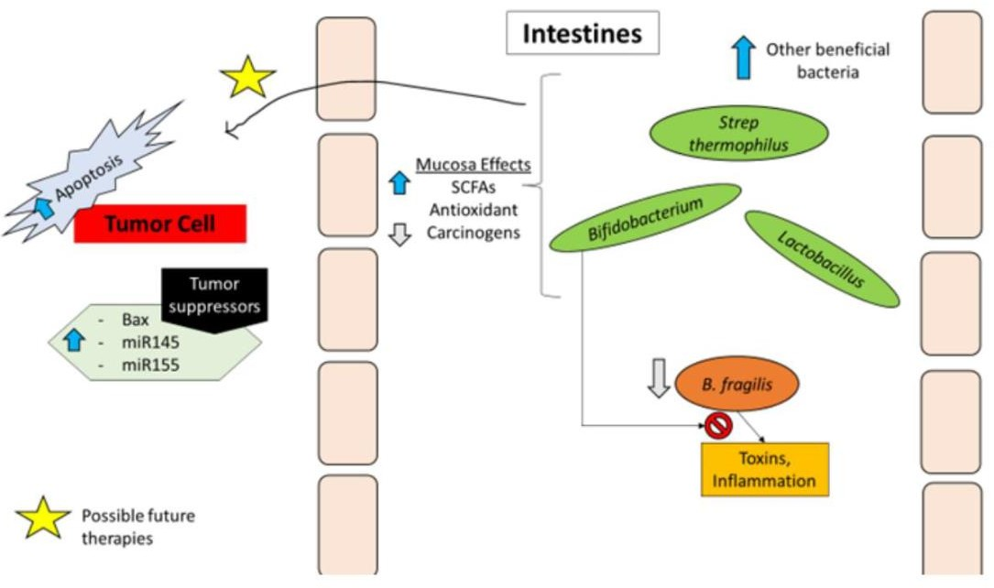

**Figure 1. Probiotic mechanisms. Probiotics increase other beneficial bacteria, while reducing pathogenic bacteria and their harmful mechanisms. They have also been shown to increase short-chain fatty acids (SCFAs) and antioxidants, while reducing carcinogens in the gut. Possible actions of probiotics are to increase tumor cell apoptosis and increase tumor suppressor genes; This may be an area that allows for further research for colorectal cancer (CRC) prevention and adjunct therapy.**

**Table 1. Probiotic Mechanism in the Body**

|  |  |
| --- | --- |
| **Non-specific physiological mechanisms** | **Immunological mechanisms** |
| Initiating antiproliferative responses and  apoptosis of colorectal cancer cells | Modulates immune function in the intestinal mucosa |
| Supports intestinal mucosal barrier function | Induces natural killer cells |
| Inhibitions of bacterial enzymatic activity  Pathogens | Assist in maturation and preservation  Immune |
| Inhibition of carcinogenic agents | Positively diversified intestinal flora  modulates T regulatory cells against tumor cells |

# Probiotics in the prevention of colorectal cancer

1. Nonspecific physiological mechanisms
   1. Initiates antiproliferative response and apoptosis of colorectal cancer cells

Apoptosis is one of the basic methods of tumor cell death. One important mechanism of cancer cells is negative regulation or resistance to the process of apoptotic cell death. In tumors, most apoptosis controls and their survival pathways get unwanted changes. These changes occur mainly in the main regulators of apoptosis, including p53. Colorectal cancer cells use the glycolysis pathway to produce energy, and this pathway produces a lot of lactate in the intestinal environment. This process is called aerobic glycolysis or the "Warburg effect" which uses enhancement Lactic extracellular, resulting in high SCFA production by *Propionbacterium,* thus blocking CRC cells at the sub-G1 stage. Dairy diet is beneficial in preventing and treating CRC due to the presence of *Lactobacillus.* These bacteria have some mechanisms of apoptosis in HT-29 and HCT-116 cells which are CRC cells through: (a) induce cytotoxin effects on cancer cells, (b) secretion of specific metabolites with cytotoxic effects, (c) positive regulation of C. fos and C. jun genes which are proto-oncogenes.15

Probiotics in another study in conjunction with aleurone are a nutrient-rich fiber source with SCFA production induced by wheat aleurone fermentation and increased butyrate production inhibiting cancer cell growth, inducing apoptosis, and differentiating cancer cells. *Bifidobacterium* inhibits CRC cell growth by stopping the cell cycle in the G0/G1 phase and increasing the activity of the *enzyme alkaline phosphatase*, a typical marker that decreases the number of cancer cells. Another important probiotic is *Bacillus polyfermenticus*, which was first used in 1993 to treat intestinal disorders and is able to produce bacteriocins and inhibit the growth of some types of cancer cells such as colon, breast, cervix, and lung and inhibit deep colonization HT-29 and Caco-2 cell lines. Antitumor mechanisms  *of Bacillus polyfermenticus* include negative regulation of ErbB2 and ErbB3 expression at mRNA and protein levels. *B. polyfermenticus* also has antitumor activity by lowering E2F levels for 6 days to 2 weeks.16

* 1. Supports intestinal mucosal barrier function

Supports intestinal mucosal barrier function through increased SCFA supplementation expression of MUC2 in intestinal epithelial cells, and the presence of colon tissue exposed to butyrate result in increased mucus synthesis. SCFA injection increases the expression of not only MUC2 but also the expression of other mucus such as MUC1, MUC3, and MUC4. Butyrate increases MUC2 gene expression, increases mucus secretion and mucosal thickness, and repairs mucosal damage by increasing cell migration to injury sites in animal models and in vitro. Regulation of mucin synthesis by SCFAs is essential so that hosts can increase colonization of beneficial bacteria so that they can compete with pathogenic bacteria.17

* 1. Inhibition of enzymatic activity of pathogenic bacteria

An imbalance of gut microbiota results in the release of large amounts of α-glucuronidase, α-glucosidase*, azoreductase, and nitroreductase* enzymes and the production of carcinogenic agents. These enzymes produce toxic metabolites such as aromatic amines, converting secondary bile salts, hydrogen sulfide, carcinogenic compounds from aglycone, acetaldehyde, and free oxygen radicals. Probiotics reduce the activity of this enzyme by various mechanisms; for example, *Lactobacillus* inhibits the ability of bacterial enzymes to reduce the dehydroxylation of primary bile acids and *L. rhamnosus* by reducing the activity of α-glucuronidase. Oral consumption of *L. acidophilus* and *Bifidobacterium* for 3 weeks can reduce the activity of the enzyme nitroreductase in feces. Concomitant consumption of vegetables and dairy products is recommended by reducing the activity of this enzyme against a diet rich in proteins and fats which is associated with an increase in the enzyme β- glucuronidase and the production of toxic compounds in the intestine.18

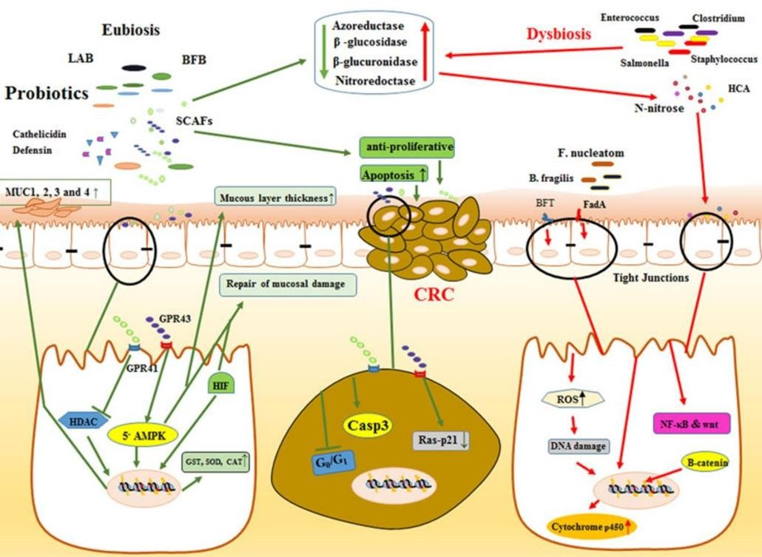

**Figure 2 Nonspecific and physiological mechanisms of probiotics in the prevention and treatment of colorectal cancer (CRC). Probiotics through the production of short-chain fatty acids (SCFAs; e.g. lactate) induce antiproliferative and apoptosis responses in CRC cells. The probiotics and SCFAs produced protect the intestinal tract by inhibiting histone deacetylases (HDACs) and increasing the expression and synthesis of mucin, such as MUC1, MUC3, and MUC4. SCFAs by activating 5α-adenosine monophosphate activated protein kinase, another important factor in maintaining hypoxia-induced factors through SCFAs and assisting and improving epithelial channel function and survival. Probiotics inhibit the enzymatic activity of pathogenic bacteria through reducing the activity of enzymes such as β-glucuronidase, β-glucosidase, azoreductase, and nitroreductase and reducing the production of carcinogenic agents. Probiotics, by applying two mechanisms (binding and deactivation) have led to the inhibition of carcinogenic agents (heterocyclic aromatic amines [HCAs]-and N-nitroses) which are potent mutagens and create carcinogenic mutations in these intestinal cells. Probiotics also, by increasing the production of antioxidant enzymes and inactivating carcinogen deactivating agents such as glutathione-S-transferase (GST), glutathione reductase, glutathione peroxidase, superoxide dismutase (SOD) and catalase (CAT) reduce their harmful effects. In addition, probiotics reduce the risk of developing CRC due to the production of metabolites that affect cytochrome p450.**

* 1. Inhibition of carcinogenic agents

Studies have shown that probiotics work by two mechanisms of attachment and inactivation to deal with carcinogens in the gut. These studies, facilitated by cell surface proteoglycans, are related to the chemical properties of mutagen factors, the pH of the intestinal environment, bacterial strains, and types of cell wall polysaccharides in cell receptor regions. One of the risk factors CRC is the high consumption of meat or meat products caused by the production of toxic *heterocyclic aromatic amines* (HCAs) during meat ripening at high temperatures. Consumption of fried meat and *L. acidophilus* together reduces mutagenicity to about 28%. Some mutagenic agents react with the intestinal mucosa and cause carcinogenic mutations in these cells. Probiotics bind to these factors (such as HCA and *N-nitrose)*  and inactivate them as well as reduce the concentration of toxic amines in putrescine, cadaverine, and tryptamine in feces.19

1. Immunological Mechanism
   1. Modulates immune function in the intestinal mucosa

Probiotics enhance immune and cellular responses by stimulating the production of anti-inflammatory, antioxidant, and anti-cancer compounds. Evidence suggests that probiotics, in their interaction with toll-like receptors (TLRs), produce anti-inflammatory cytokines, TNF production in epithelial cells, inhibit NF-kB in macrophages, and IL8 production is required to call neutrophils. Some species  *of Lactobacillus* may also increase Treg activity; increase the antibacterial phagocytic activity of neutrophils in peripheral blood and natural killer cell activity. Probiotic bacterial cells and their solutes tend to induce effects on systemic immune responses by stimulating antigen-presenting cells in the gastrointestinal tract (Figure 3).

There is evidence that SCFAs can moderate oxidative stress, possibly by controlling HDAC. In human studies, it has been shown that levels serum is higher than reactive oxygen species with an increased risk of CRC. In addition, oxidative stress causes inflammation of the colon. Laboratory studies have shown that butyrate and the physiological composition of acetate, propionate, and butyrate protect colonocytes from DNA damage caused by reactive types of oxygen. In addition, SCFAs protect the mucosal lining from damage by lowering the level of immune modulators, such as prostaglandins, formed by cyclooxygenase 2 (COX-2). Prostaglandin E2 causes inflammation and tumor growth in colon cancer, and greater levels of COX-2 mRNA in colon cancer tissue. Laboratory studies show that butyrate can reduce COX-2 expression in cancer tissue, thereby preventing the harmful effects of prostaglandins in the mucosal layer.20 The complex effects of SCFAs on colon health and disease are linked to various mechanisms. SCFAs have been shown to provide energy for colonocytes and connect to GPRs to activate downstream signaling pathways. They also inhibit HDAC in colonocytes and mucosal immune cells. HDAC is an enzyme that prevents DNA transcription and thus regulates gene expression. Studies on colon cancer cells have shown that butyrate is a powerful HDAC inhibitor. Propionate had a moderate effect on HDAC inhibition in the colon, but acetate did not affect.21 SCFAs inhibit HDAC in colonocyte cells and mucosal immune cells and regulate the gene expression of these cells. Inhibition of HADC, therefore, leads to inhibition of NF-kB in several cell types in the immune system Mucosa copy gene related inflammatory, including those that code for cytokines.

SCFAs bind to various GPRs, such as GPR41, GPR43, and GPR109a, on the surface of apical colonocytes and immune cells, thereby activating several signaling pathways. In particular, activation of GPR43 by acetate and propionate and activation of GPR109a by butyrate appear to play an important role in suppressing the inflammatory response. These receptors are expressed in the apical membrane of colonocytes and enterocytes, as well as colonic immune cells, which carry out the inflammatory process by suppressing NF-αB expression and increasing Treg cell differentiation in the colon. Activating GPR43 and GPR41 both reduces colon inflammation. This reduction in inflammation is achieved by suppressing the expression of adhesion molecules in inflammatory cells and endothelial cells, which is done by preventing chemotaxisis of monocytes from inflammation, and by regulating Treg cell function. Activating butyrate via GPR109a also influences the inflammatory process by suppressing NF-αB expression and increasing Treg cell differentiation. These receptors are expressed primarily by enteroendocrine L cells and less by mast cells and leukocyte cells in the intestine, so they play an important role in intestinal inflammatory reactions. Once SCFAs bind to GPR41 and GPR43, downstream signaling pathways, such as the signaling MAPK protein, are activated, leading to chemokine and cytokine production, and regulation of cell proliferation. In addition to SCFAs, various biological agents derived from probiotics include exopolysaccharides (EPS), peptidoglycan, monolayer proteins, lipo teicoic acid, conjugated linoleic acid, and peptides, as well as in the regulation of the immune system.15

* 1. Induces natural killer cells

Most of the various mechanisms of anticancer activity of probiotics have been derived from animal studies. Among these effects, one of them is an increase or restoration of the cellular activity of NK. Some researchers investigated the mechanism of L. *casei*'s anticancer effects using mutations that lack NK cell activity. NK cells are essential for controlling immunity against cancer and infection, and more NK cell activity is associated with a lower risk of cancer. Because NK cell activity can change with a variety of environmental factors such as aging, severe psychological stress, smoking, and chronic infections, NK cellular activity is a promising goal for probiotics.22

Probiotic intact cell walls are required to induce IL-12, bacteria absorbed by macrophages have a remarkable effect of resistance to digestion. Probiotic cell walls resistant to intracellular digestion effectively stimulate macrophages to secrete large amounts of IL-12.23 Intraperitoneal injection of Langerhans cells (LCs) in mice inhibited the growth of tumors made in the chest and also led to long survival in humans. Also, by stimulating the production of interferon-α1, IL-12, and TNF-α, the balance of T cells is directed to Th1 and stimulates NK cells. Results of a 2007 study by Takeda et al. In healthy volunteers showed a continuous positive effect of LC intake on NK cell activity.24 Animal studies have also shown an increase in the number and cytotoxicity of cells natural lethality after probiotic treatment. increased immunity of host cells is evidenced by an increase in the number of Lymphosite CD4/CD8+ and phagocytosis ability of macrophages (Figure 3).

# 3. Conclusion

Probiotics are "live microorganisms, providing health benefits to the host when administered in adequate amounts". There has been a lot of research related to the role of probiotics in efforts to prevent the occurrence of colorectal cancer (CRC) cases through two mechanisms in the form of non-specific physiological mechanisms such as initiating antiproliferative responses and apoptosis of colorectal cancer cells, supports the barrier function of the intestinal mucosa, inhibition of the enzymatic activity of pathogenic bacteria, inhibition of carcinogenic agents. As well as immunological mechanisms by modulating immune function in the intestinal mucosa and inducing natural killer cells. Certain bacteria, such as Fusobacterium and Peptostreptococcus, have been shown to be associated with the pathogenesis of colon cancer whereas Lactobacillus and Bifidobacterium have been shown to protect against cancer. Microbial metabolites such as short-chain fatty acids (SCFAs) have been shown to play pro-apoptotic, anti-proliferative, and anti-cancer roles. Their influence on epigenetics in terms of acting as histone deacetylase inhibitors and activation of pro-apoptotic genes can subsequently be exploited in such a way that it can be used as primary therapy or adjunct to currently available therapies.

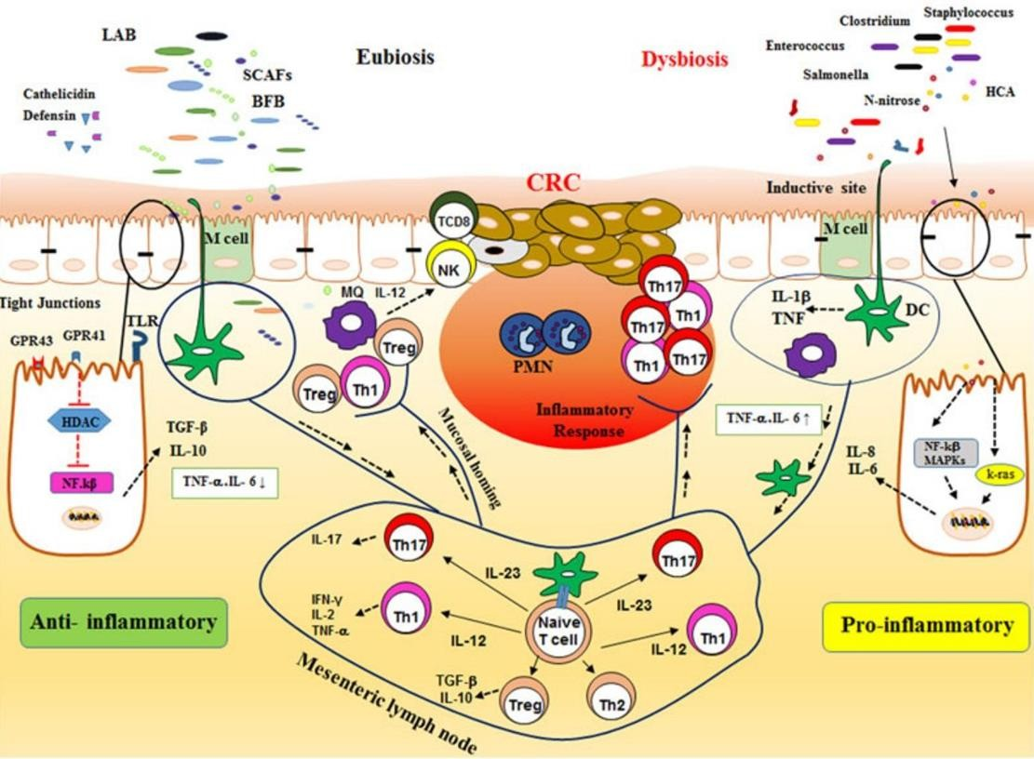

**Figure 3 Effect of probiotics on performance of immunological mechanisms. Chronic and uncontrolled inflammation plays an important role in the induction and development of cancer. Expression of tumor oncogenes, including k-ras, leads to increased expression of inflammatory cytokines (e.g., IL-8). Subsequent infiltration of immune cells leads to the development and angiogenesis of colon cancer. During eubiosis,The dominant anti-inflammatory cytokines such as TGF-α and IL-10 are involved in epithelial cells, Treg, and relieve colon inflammation. SCFAs inhibit HDAC in colonocyte cells and mucosal immune cells and cause inhibition of transcription factor NF-kB. In addition, it directly inhibits TLR-4 receptor signaling and produces cytokines such as TNF-α, IL-6, and IL-12 directly suppressing the immune response. SCFAs cause differentiation in Treg cells (play an important role in limiting the intestinal inflammatory response through the production of IL-10), mucosa with HDAC inhibition and cause inhibition and reduction in the number of inflammatory cytokines. The binding of SCFAs to the G.2PR range activates several signaling pathways, inflammatory processes by suppressing NF-kB, enhancing Treg cell differentiation. In addition, probiotics and their products in clones prevent chemotaxisis of monocytes against inflammation and adjust the function of Treg cells. NK cells play a role in controlling immunity against cancer, in the presence of probiotics, NK cell activity is enhanced by inducing IL-12 production by active monocytes/macrophages, and increasing TCD8 infiltration in tumors. GPR: G-paired receptors; HDAC: histone deacetylase; IL: interleukin; NF-kB: factors nuclear-kB; NK cells: natural killer cells; SCFAs: short-chain fatty acids; TGF-α: changing growth factors α; TLR: toll-like receptor; Treg: regulatory T cell**

# References

1. Azril Okta Ardhiansyah. KANKER KOLOREKTAL [Internet]. Vol. 5, Jurnal Averrous. 2019 [cited 2023 Feb 24]. Available from: https://books.google.co.id/books?id=ujm2 DwAAQBAJ}, year={2019}
2. Hidayat A, Maipa A, RahayuAans Saputri S, Himawan A, Kunci K. Pengaruh Fermentasi Liofilisat Kefir Rosella (Hibiscus sabdarifa L.) Terhadap Kadar Polifenol Total. Hasanuddin Student Journal. 2018;2(1):208–11.
3. Larsson SC WA. Meat consumption and risk of colorectal cancer: a meta-analysis of prospective studies. 2020;
4. McMillan, D.C., Canna, K., & McArdle, C.S. (2020). Systemic inflammatory response predicts survival following curative resection of colorectal cancer. British Journal of Surgery, 90, 215–219.
5. Davis CD, Milner JA: Gastrointestinal microflora, food components and colon cancer prevention. J Nutr Biochem 2020, 20:743-752. spanish;
6. Rafter J: The effects of probiotics on colon cancer development. Nutr Res Rev 2019, 17:277-284. Bandung;
7. Nicholson, J. K., Holmes, E., Kinross, J., Burcelin, R., Gibson, G., Jia, W., & Pettersson, S. (2021). Host‐gut microbiota metabolic interactions. Science, 336(6086), 1262–1267. Sumatera Selatan;
8. Food and Agriculture Organization of the United Nations. Probiotics in food. Available online: http://www.fao.org/3/a- a0512e.pdf (accessed on 18 Februari 2023).
9. Zhu, B.; Wang, X.; Li, L. Human gut microbiome: The second genome of human body. Protein Cell 2022, 1, 718–725, doi:10.1007/s13238-010-0093-z.
10. Bermudez-Brito, M.; Plaza-Díaz, J.; Muñoz- Quezada, S.; Gómez-Llorente, C.; Gil, A. Probiotic mechanisms of action. Ann. Nutr. Metab. 2019, 61, 106–74, doi:10.1159/000342079.
11. Gogineni, V.K.; Morrow, L.E.; Malesker, M.A. Probiotics: Mechanisms of action and clinical applications. J. Probiotics Health 2019, 1, 2, doi:10.4172/jph.10000101.
12. Zhou, S.; Chen, J.; Yao, H.; Hu, H. Fusobacterium and Colorectal Cancer. Front. Oncol. 2020, 8, 371, doi:10.3389/fonc.2018.00371.
13. Haghi, F.; Goli, E.; Mirzaei, B.; Zeighami, H. The association between fecal enterotoxigenic B. fragilis with colorectal cancer. BMC Cancer 2019, 19, 879, doi:10.1186/s12885-019-6115-1.
14. Raisch, J.; Buc, E.; Bonnet, M.; Sauvanet, P.; Vazeille, E.; de Vallée, A.; Déchelotte, P.; Darcha, C.; Pezet, D.; Bonnet, R.; et al. Colon Cancer-Associated B2 Escherichia Coli Colonize Gut Mucosa and Promote Cell Proliferation. World J. Gastroenterol. 2019, 20, 6560–6572, doi:10.3748/wjg.v20.i21.6560.
15. Sharma, M., & Shukla, G. (2020). Metabiotics: One step ahead of probiotics; an insight into mechanisms involved in anticancerous effect in colorectal cancer. Frontiers in Microbiology, 7, 1940.
16. Ma, EL, Choi, YJ, Choi, J., Pothoulakis, C., Rhee, SH, & Im, E. (2019).The anticancer effect of probiotic Bacillus polyfermenticus on human colon cancer cells is mediated through ErbB2 and ErbB3 inhibition.nternational Journal of Cancer, 127(4), 780–790. Available from: <http://repository.itspku.ac.id/id/eprint/18> 1
17. Wangko WS. Aspek Fisiologik Short Chain Fatty Acid (SCFA). Medical Scope Journal. 2020 Jul 27;2(1).
18. Vernazza, C. L., Rabiu, B. A., & Gibson, G. R. (2019). Human colonic microbiology and the role of dietary intervention: Introduction to prebiotics. Prebiotics: Development and Application, 2006, 1–28.
19. Raman , M. , Ambalam , P. , Kondepudi , KK , Pithva , S. , Kothari , C. , Patel , A .T., ... Vyas, B. (2019). Potential of probiotics, prebiotics and synbiotics for management of colorectal cancer. Gut Microbes, 4(3), 181–192.
20. dos Reis SA, da Conceição LL, Siqueira NP, Rosa DD, da Silva LL, Peluzio M do CG. Review of the mechanisms of probiotic actions in the prevention of colorectal cancer. Vol. 37, Nutrition Research. Elsevier Inc.; 2017. p. 1–19.
21. Eslami M, Yousefi B, Kokhaei P, Hemati M, Nejad ZR, Arabkari V, et al. Importance of probiotics in the prevention and treatment of colorectal cancer. Vol. 234, Journal of Cellular Physiology. Wiley-Liss Inc.; 2019. p. 17127–43.
22. Takagi, A., Matsuzaki, T., Sato, M., Nomoto, K., Morotomi, M., & Yokokura, T.(2019). Enhancement of natural killer cytotoxicity delayed murine [Internet]. [cited 2021 Jul 27]. Available from: https://baznas.go.id/index.php/id/zakat- penghasilan
23. Delcenserie, V., Martel, D., Lamoureux, M., Amiot, J., Boutin, Y., & Roy, D.(2019). Immunomodulatory effects of probiotics in the intestinal tract. Current Issues in Molecular Biology, 10(1/2), 37–54.
24. Takeda, K., & Okumura, K. (2007). Effects of a fermented milk drink containing Lactobacillus casei strain Shirota on the human NKÿcell activity. The Journal of Nutrition, 137(3), 791S–793S.